

**ONLINE SHOPPING**

**Software Design Document**

– Hanoi, September 2021 –

**Table of Contents**

I. Overview **8**

Code Packages/Namespaces 8

**II. Code Designs** **10**

1. Feature Product 10

a. Class Diagram 10

b. Class Specifications 10

c. Sequence Diagram(s) 10

d. Database queries 10

2. Search & Filter Product 10

a. Class Diagram 10

b. Class Specifications 10

c. Sequence Diagram(s) 11

d. Database queries 11

3. View Product Detail 12

a. Class Diagram 12

b. Class Specifications 12

c. Sequence Diagram(s) 12

d. Database queries 12

4. Change Amount 13

a. Class Diagram 13

b. Class Specifications 13

c. Sequence Diagram(s) 14

d. Database queries 14

5. Delete Product From Cart 15

a. Class Diagram 15

b. Class Specifications 15

c. Sequence Diagram(s) 16

d. Database queries 16

6. Delete All Cart Item 16

a. Class Diagram 17

b. Class Specifications 17

c. Sequence Diagram(s) 17

d. Database queries 18

7. Login 18

a. Class Diagram 18

b. Class Specifications 19

c. Sequence Diagram(s) 20

d. Database queries 20

8. Register 20

a. Class Diagram 20

b. Class Specifications 21

c. Sequence Diagram(s) 22

d. Database queries 22

9. View User List 23

a. Class Diagram 23

b. Class Specifications 23

c. Sequence Diagram(s) 24

d. Database queries 24

10. Edit User 25

a. Class Diagram 25

b. Class Specifications 25

c. Sequence Diagram(s) 27

d. Database queries 27

11. Delete User 27

a. Class Diagram 27

b. Class Specifications 27

c. Sequence Diagram(s) 28

d. Database queries 28

12. Customers List[Seller] 29

a. Class Diagram 29

b. Class Specifications 29

c. Sequence Diagram(s) 29

d. Database queries 29

13. Add Ship Information 29

a. Class Diagram 29

b. Class Specifications 29

c. Sequence Diagram(s) 30

d. Database queries 30

14. Change Ship Information 30

a. Class Diagram 30

b. Class Specifications 31

c. Sequence Diagram(s) 31

d. Database queries 31

15. Reset Password 31

a. Class Diagram 31

b. Class Specifications 32

c. Sequence Diagram(s) 32

d. Database queries 32

16. Change Password 32

a. Class Diagram 32

b. Class Specifications 32

c. Sequence Diagram(s) 33

d. Database queries 33

17. User Profile 34

a. Class Diagram 34

b. Class Specifications 34

c. Sequence Diagram(s) 35

18. My Orders 35

a. Class Diagram 35

b. Class Specifications 35

c. Sequence Diagram(s) 36

d. Database queries 36

19. Order Information 37

a. Class Diagram 37

b. Class Specifications 38

c. Sequence Diagram(s) 38

d. Database queries 38

20. View Product List 38

a. Class Diagram 38

b. Class Specifications 38

c. Sequence Diagram(s) 38

d. Database queries 38

21. Orders List 38

a. Class Diagram 38

b. Class Specifications 38

c. Sequence Diagram(s) 38

d. Database queries 38

22. Order Details 38

a. Class Diagram 38

b. Class Specifications 38

c. Sequence Diagram(s) 38

d. Database queries 38

23. View Feedback 38

a. Class Diagram 38

b. Class Specifications 39

c. Sequence Diagram(s) 39

d. Database queries 39

24. Send Feedback 40

a. Class Diagram 40

b. Class Specifications 40

c. Sequence Diagram(s) 40

d. Database queries 40

25. Blogs List 40

a. Class Diagram 40

b. Class Specifications 40

c. Sequence Diagram(s) 41

d. Database queries 41

26. Blog Details 42

a. Class Diagram 42

b. Class Specifications 42

c. Sequence Diagram(s) 42

d. Database queries 43

27. Blog Management 43

a. Class Diagram 43

b. Class Specifications 43

c. Sequence Diagram(s) 44

d. Database queries 44

28. View Notification 45

a. Class Diagram 45

b. Class Specifications 45

c. Sequence Diagram(s) 45

d. Database queries 45

29. Mark as Read 45

a. Class Diagram 45

b. Class Specifications 46

c. Sequence Diagram(s) 46

d. Database queries 46

30. Admin Feature 46

a. Class Diagram 47

b. Class Specifications 47

c. Sequence Diagram(s) 47

d. Database queries 47

31. Orders Dashboard 48

a. Class Diagram 48

b. Class Specifications 48

c. Sequence Diagram(s) 48

d. Database queries 48

32. Error 48

a. Class Diagram 48

b. Class Specifications 48

c. Sequence Diagram(s) 48

d. Database queries 48

III. Database Tables **49**

1. Database Schema 49

2. Table Description 50

# I. Overview

## Code Packages/Namespaces

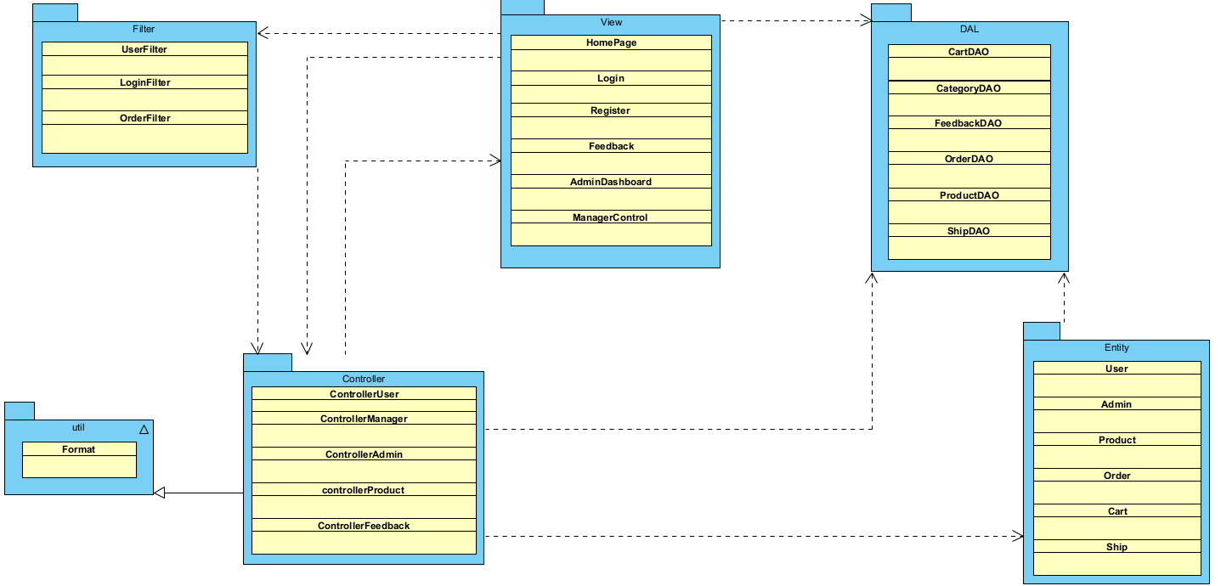

***Package descriptions & package class naming conventions***

|  |  |  |
| --- | --- | --- |
| **No** | **Package** | **Description** |
| *01* | *View(Web Pages)* | *Provide interaction with user ,GUI*  *Java Class Naming Convention* |
| *02* | *Controller* | *Control the data flow between view and model (DAO),Control the logic of the system*  *Java Class Naming Convention* |
| *03* | *DAL* | *Provide the connection to the Database, Extract data for the system* |
| *04* | *Filter* | *Control the redirection between Pages in View and from View to Controller*  *Java Class Naming Convention* |
| *05* | *Entity* | *Define the logic of data extracted from Database*  *Java Class Naming Convention* |
| *06* | *Util* | *Utility Function* |

# II. Code Designs

## 1. Feature Product

### a. Class Diagram

### b. Class Specifications

### c. Sequence Diagram(s)

### d. Database queries

## 2. Search & Filter Product

### a. Class Diagram

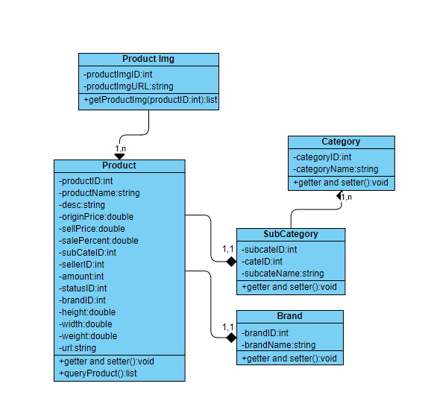

### b. Class Specifications

Product

|  |  |  |
| --- | --- | --- |
| **No** | **Method** | **Description** |
| *01* | *getProductQuery(Query,subcate,brand,price,sortType,sortMode)* | *Query product from database with input parameter* |

### c. Sequence Diagram(s)

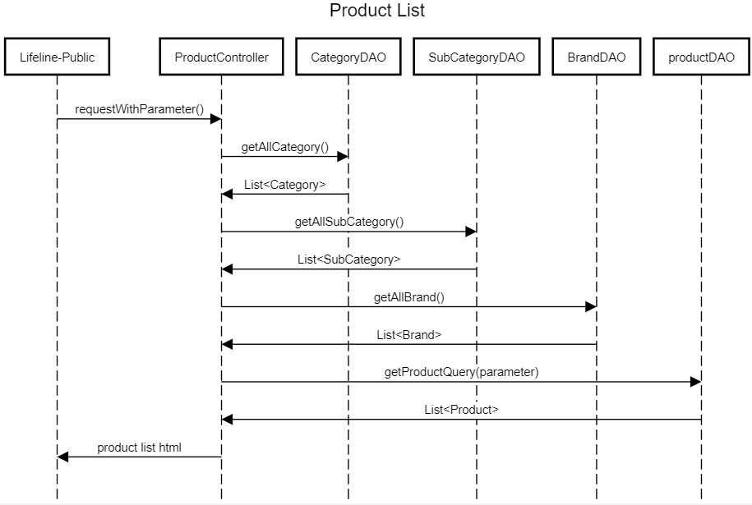

### d. Database queries

* SELECT * FROM dbo.ProductImg where ProductID = ?
* SELECT p.ProductID , ProductName , Description , OriginalPrice , SellPrice , SalePercent , SubCategoryID , SellerID , Amount , StatusID , StatusID ,BrandID , height , width ,weight , s.ProductImgURL from Product p join ProductImg s on p.ProductID = s.ProductID WHERE p.ProductName LIKE ? AND p.StatusID!= 2 AND p.Amount>0 [ AND SubCategoryID = ? ] [ AND BrandID = ? ] [AND p.SellPrice< ? AND p.SellPrice>= ? ] [ ORDER BY [ parameter ] ] [ ASC /DESC ]

## 3. View Product Detail

### a. Class Diagram

### b. Class Specifications

|  |  |  |
| --- | --- | --- |
| **No** | **Method** | **Description** |
| *01* | *GetProductDetailsByProductID* | *Traverse from beginning to end all rows in the product table in the database* |

### c. Sequence Diagram(s)

### d. Database queries

SELECT * from Product

JOIN ProductImg

ON Product.ProductID = ProductImg.ProductID

WHERE Product.ProductID = ?

## 4. Change Amount

### a. Class Diagram

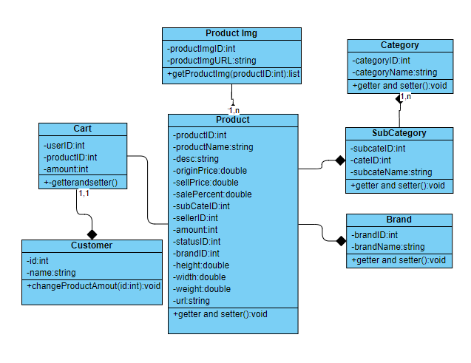

### b. Class Specifications

Customer

|  |  |  |
| --- | --- | --- |
| **No** | **Method** | **Description** |
| *01* | *changeProductAmount()* | *Add or reduce amount of a product from cart* |

### c. Sequence Diagram(s)

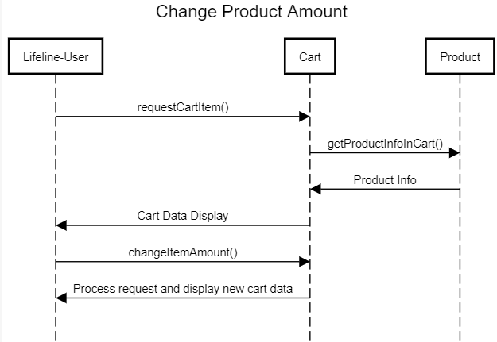

### d. Database queries

UPDATE dbo.cart

SET amount = ?

WHERE userID = ? and productID = ?

## 5. Delete Product From Cart

### a. Class Diagram

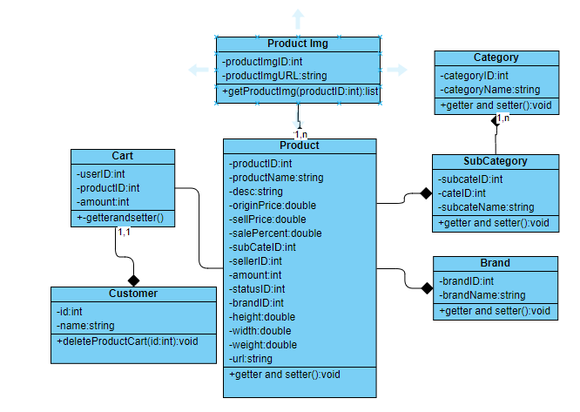

### b. Class Specifications

Customer

|  |  |  |
| --- | --- | --- |
| **No** | **Method** | **Description** |
| *01* | *deleteProductCart()* | *Remove a product() from cart* |

### c. Sequence Diagram(s)

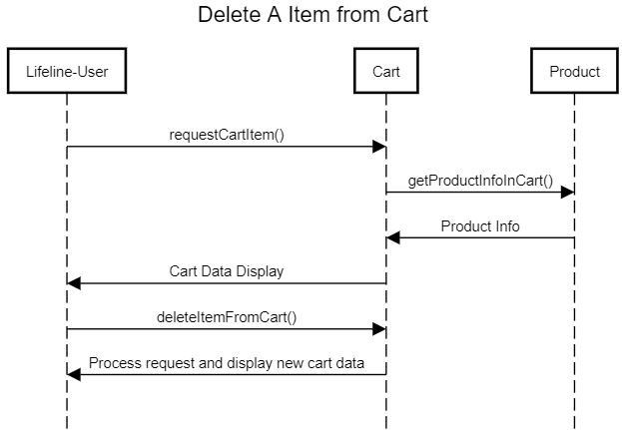

### d. Database queries

DELETE FROM *dbo.cart* WHERE *userID= ? and* productID = ?

## 6. Delete All Cart Item

### a. Class Diagram

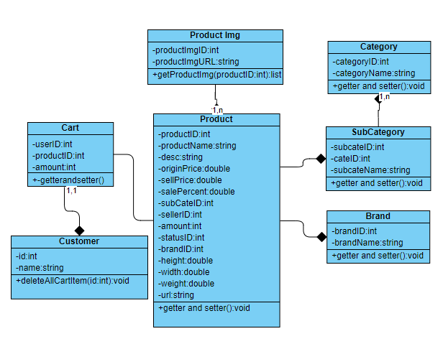

### b. Class Specifications

Customer

|  |  |  |
| --- | --- | --- |
| **No** | **Method** | **Description** |
| *01* | *deleteAllCartItem()* | *Remove every item from cart* |

### c. Sequence Diagram(s)

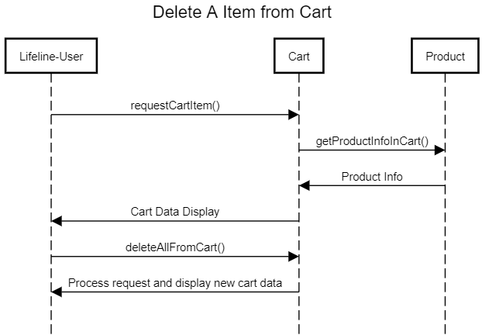

### d. Database queries

DELETE FROM *dbo.Cart* WHERE *UserID = ?*;

## 7. Login

### a. Class Diagram

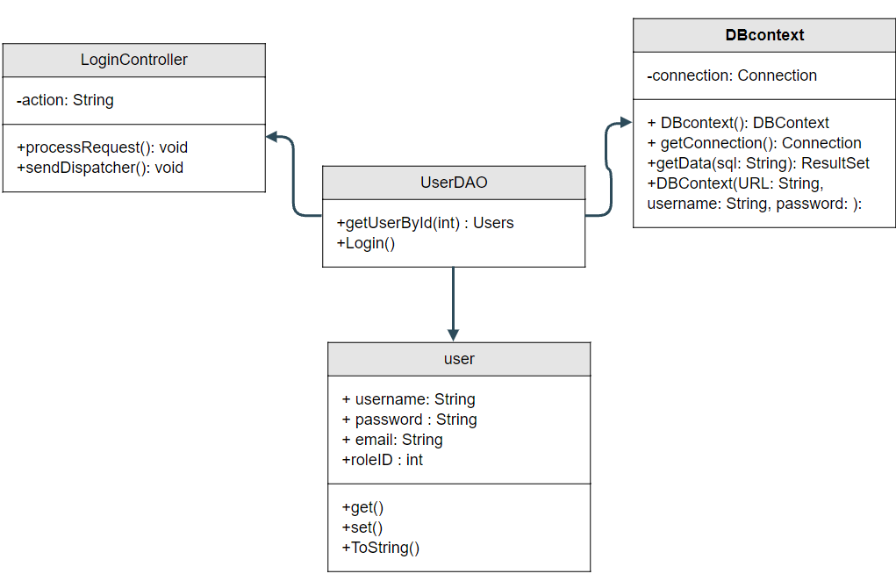

### b. Class Specifications

UserController

|  |  |  |
| --- | --- | --- |
| No | Method | Description |
| 01 | processRequest() | get all new information from user Form and update the database |
|  |  |  |

UserDAO

[Provide the detailed description for the class methods]

|  |  |  |
| --- | --- | --- |
| No | Method | Description |
| 01 | getUserList() | get the list of user |
| 02 | getUserById(int uId) | get the user where the user id is |

### 

### c. Sequence Diagram(s)

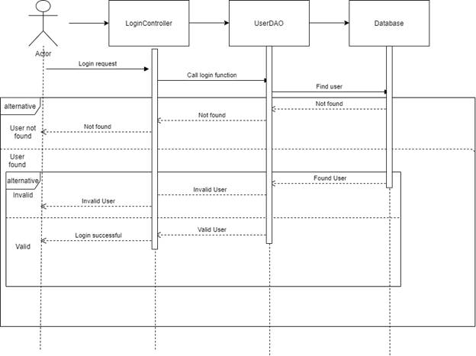

### d. Database queries

**"select * from [User] where username=? and password=?";**

## 8. Register

### a. Class Diagram

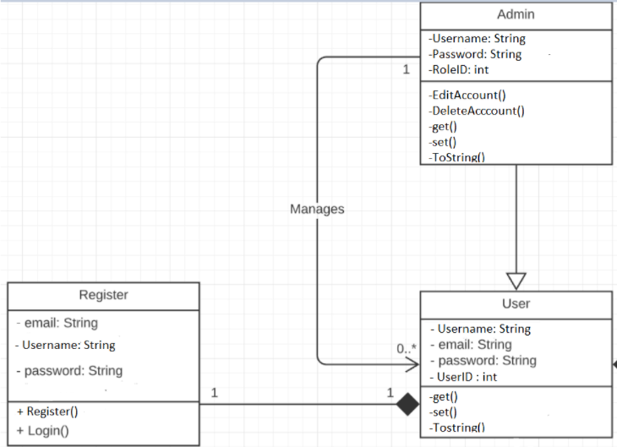

### b. Class Specifications

UserDAO

[Provide the detailed description for the class methods]

|  |  |  |
| --- | --- | --- |
| No | Method | Description |
| 01 | Register( String username,String password, String mai) | insert a new user with Name , Pass, Mail) |
| 02 | checkAccount(String xName) | - check if the username is already exist  - return null |

UserController

Class Methods

[Provide the detailed description for the class methods]

|  |  |  |
| --- | --- | --- |
| No | Method | Description |
| 01 | processRequest | get all new information from user Form and update the database |

### 

### c. Sequence Diagram(s)

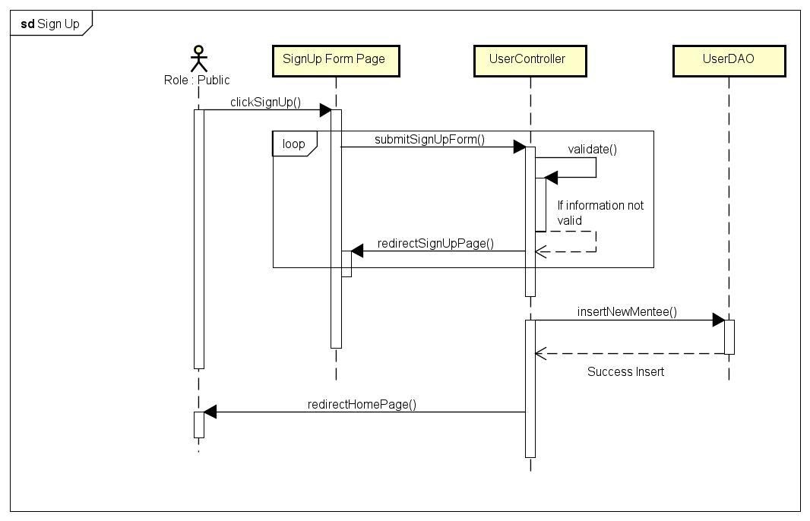

### d. Database queries

**+insert into [User] value(?,?,?,?,3,1)**

## 9. View User List

### a. Class Diagram

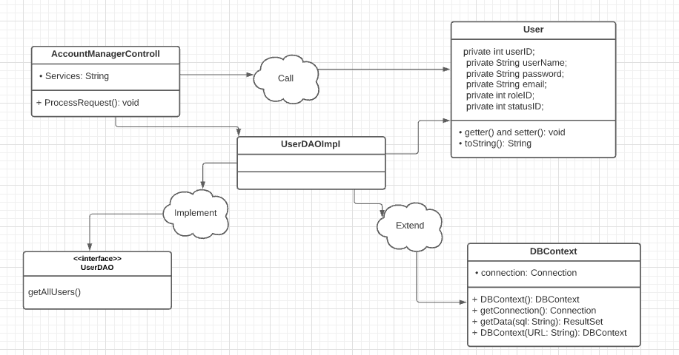

### b. Class Specifications

* AccountManagerControll:

|  |  |  |
| --- | --- | --- |
| No | Method | Description |
| 01 | processRequest() | - *Return: Null*  - *Parameter: HttpServletRequest request, HttpServletResponse response*  - *Receive request from client and process data with Database, then return a list containing all users and put that data to jsp page* |

* UserDAO:

|  |  |  |
| --- | --- | --- |
| No | Method | Description |
| 01 | getAllUsers() | - Return: List<User>  - Parameter: No  - Get all the users in the database and return a list of users |

### c. Sequence Diagram(s)

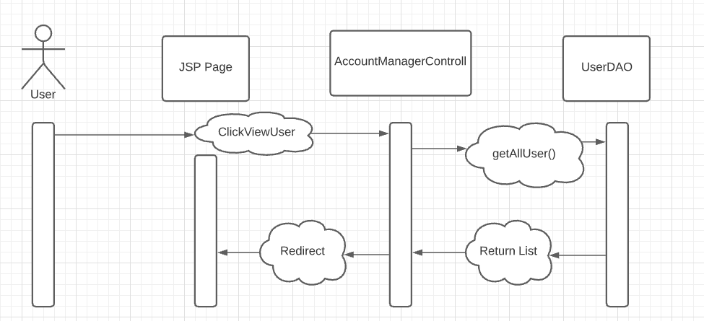

### d. Database queries

* select * from Users

## 10. Edit User

### a. Class Diagram

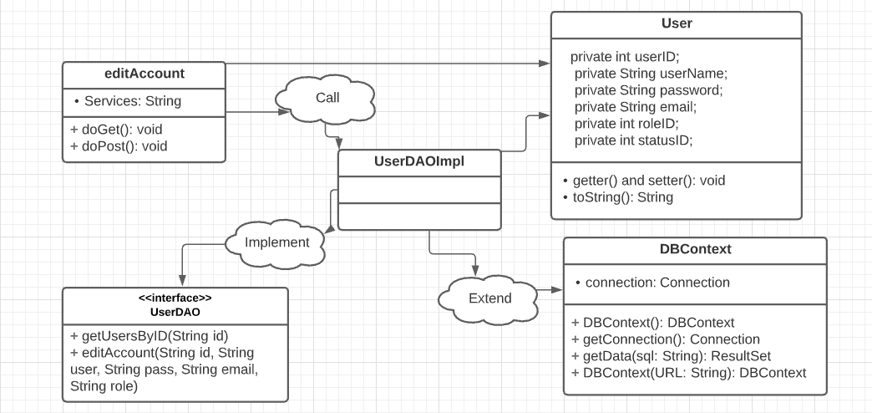

### b. Class Specifications

* editAccount:

|  |  |  |
| --- | --- | --- |
| No | Method | Description |
| 01 | processRequest() | - *Return: Null*  - *Input: Service (createUser)*  - *Get data from Form in AccountManager.JSP page and process them, and update that User into DB and direct to the AccountManager.JSP page* |
| 02 | doGet() | * Get user by UserID from the database, and load current his/her information to textbox |
| 03 | doPost() | * Update User’s information in to database |

* UserDAO:

|  |  |  |
| --- | --- | --- |
| No | Method | Description |
| 01 | editAccount | - *Return: new User*  - *Input: All properties of entity User*  - *Update the User entered on AccountManager.JSP page to database* |
| 02 | getUsersByID | - *Return: ‘A user’ or ‘Null’*  - *Input: UserID*  - *Find User by UserID* |

### c. Sequence Diagram(s)

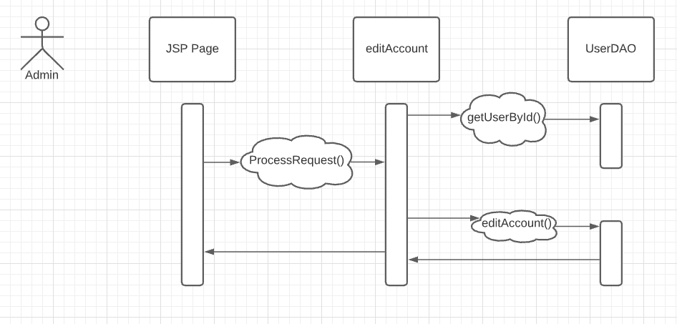

### d. Database queries

* select * from Users where UserID = ?
* UPDATE Users SET Username = ?, Password = ?, email = ?, RoleID = ? WHERE UserID = ?

## 11. Delete User

### a. Class Diagram

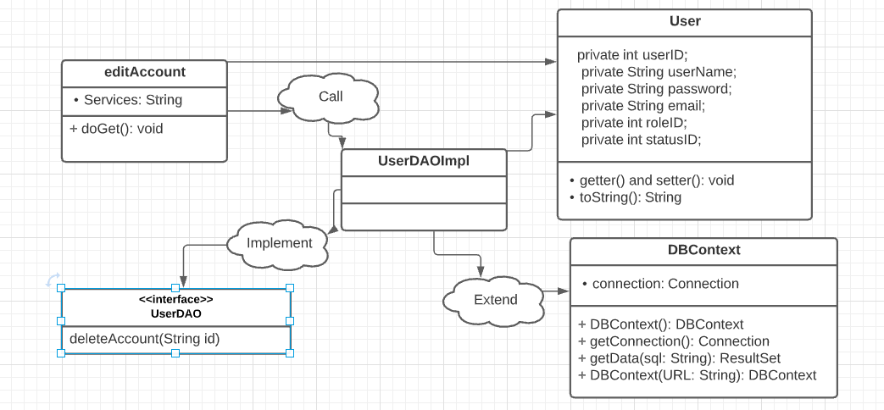

### b. Class Specifications

* deleteAccount:

|  |  |  |
| --- | --- | --- |
| No | Method | Description |
| 01 | processRequest() | - *Return: Null*  - *Input: Service (deleteUser)*  - *Get data from Form in AccountManager.JSP page and process them, and delete that User into DB and direct to the AccountManager.JSP page* |

* UserDAO:

|  |  |  |
| --- | --- | --- |
| No | Method | Description |
| 01 | deleteAccount | - *Return: New list of user*  - *Input: UserID of a user*  - *Delete the User entered on AccountManager.JSP page to database* |

### c. Sequence Diagram(s)

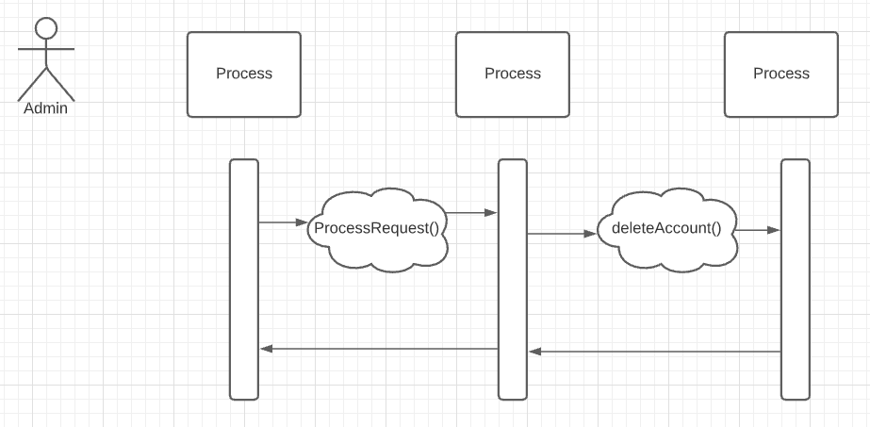

### d. Database queries

* delete from Users where UserID = ?

## 11. Search User

**a. Class Diagram**

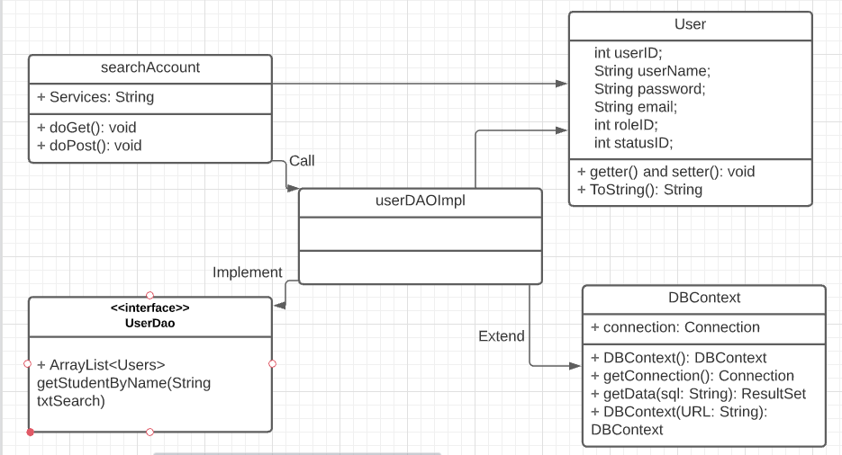

### b. Class Specifications

- searchAccount:

|  |  |  |
| --- | --- | --- |
| No | Method | Description |
| 01 | doGet() | * Navigate to the SearchAccount.jsp . page |
| 02 | doPost() | * Get List of Users from database by the first letter of his or her name * Navigate to the SearchAccount.jsp . page |

- UserDao:

|  |  |  |
| --- | --- | --- |
| No | Method | Description |
| 01 | ArrayList<Users> getStudentByName(String txtSearch) | - *Return: List of user*  *- Input:* The first letter of his or her name  - *Search for a user whose first letter is the same as the one entered by the admin and entered on SearchAccount.JSP page* |

### c. Sequence Diagram(s)

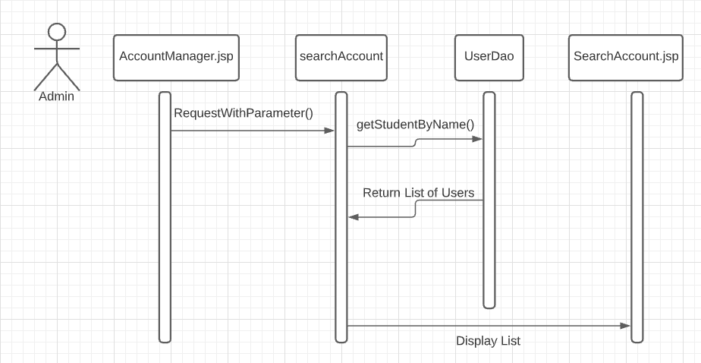

### d. Database queries

+ SELECT * FROM Users where UserName like '" + txtSearch + "%'

## 12. Customers List[Seller]

### a. Class Diagram

### b. Class Specifications

### c. Sequence Diagram(s)

### d. Database queries

## 13. Add Ship Information

### a. Class Diagram

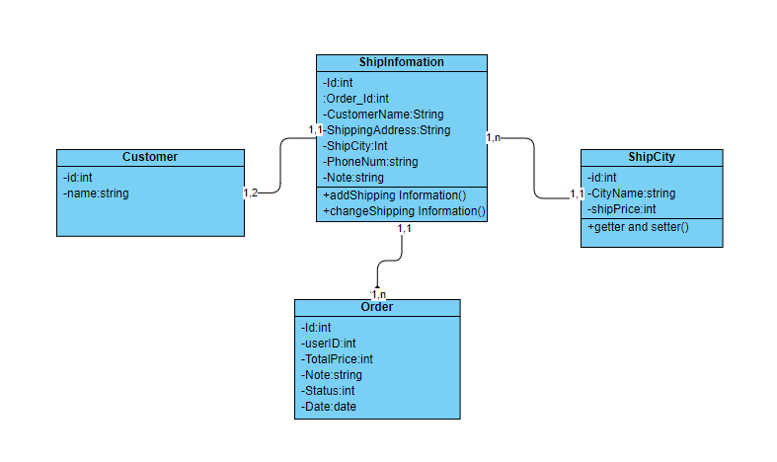

### b. Class Specifications

Ship Information Class

|  |  |  |
| --- | --- | --- |
| **No** | **Method** | **Description** |
| *01* | *addShipping information()* | *Add New Shipping information for account* |

### c. Sequence Diagram(s)

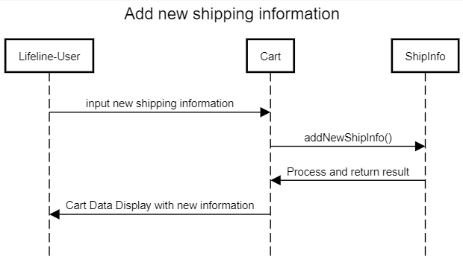

### d. Database queries

INSERT INTO dbo.ShipInfo(order_id,customerName,shippingAddress,ShipCity,PhoneNum,Note) VALUES(?,?,?,?,?,?)

## 14. Change Ship Information

### a. Class Diagram



### b. Class Specifications

Ship Information Class

|  |  |  |
| --- | --- | --- |
| **No** | **Method** | **Description** |
| *01* | *changeShipping information()* | *Change existing shipping information for current order* |

### c. Sequence Diagram(s)

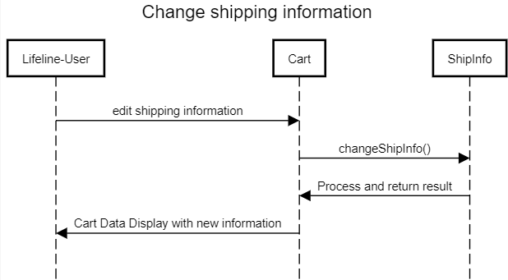

### d. Database queries

Update dbo.ShipInfomation

SET CustomerName=?,ShippingAddress=?,ShipCity=?,PhoneNum=?,Note=?

Where orderID = ?

## 15. Reset Password

### a. Class Diagram

### b. Class Specifications

### c. Sequence Diagram(s)

### d. Database queries

## 16. Change Password

### a. Class Diagram

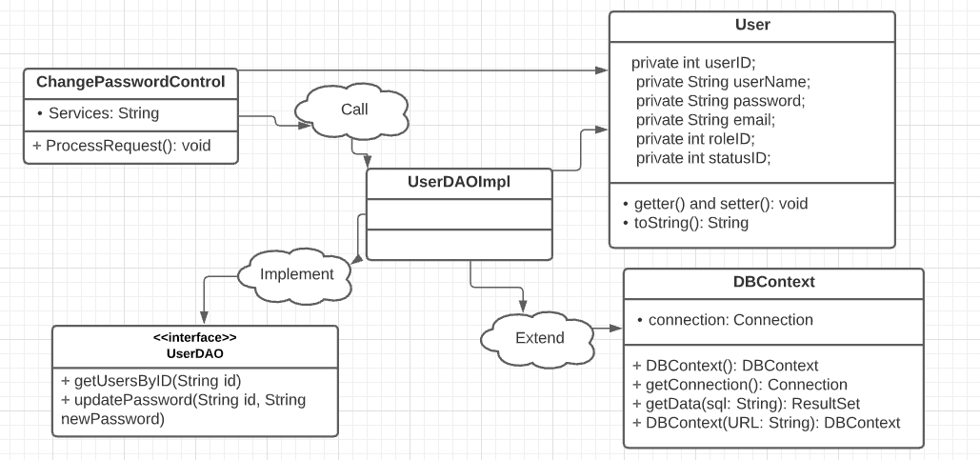

### b. Class Specifications

* ChangePasswordControl:

|  |  |  |
| --- | --- | --- |
| No | Method | Description |
| 01 | processRequest() | - *Return: Null*  **- Parameter: HttpServletRequest request, HttpServletResponse response** |

* UserDAO:

|  |  |  |
| --- | --- | --- |
| No | Method | Description |
| 01 | getUsersByID() | - *Return: ‘A user’ or ‘Null’*  - *Input: UserID*  - *Find User by UserID* |
| 02 | updatePassword() | - *Return: void*  - Parameter: input string  - *Input: UserID, newPassword*  - *Update this new password into database* |

### c. Sequence Diagram(s)

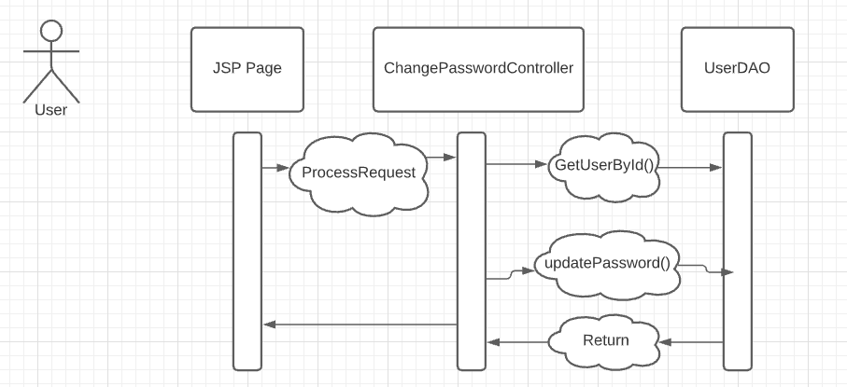

### d. Database queries

* select * from Users where UserID = ?
* UPDATE Users SET Password = ? WHERE UserID = ?

## 17. User Profile

### a. Class Diagram

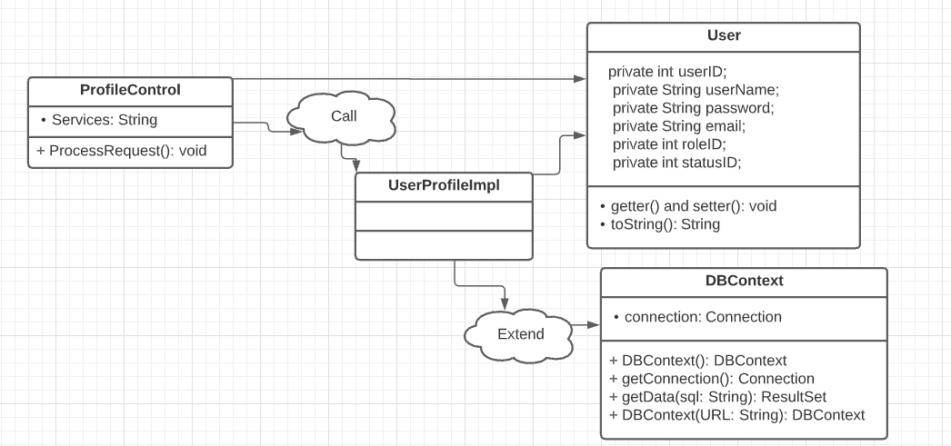

### b. Class Specifications

* ProfileControll:

|  |  |  |
| --- | --- | --- |
| No | Method | Description |
| 01 | processRequest() | get all user information from the database |

### c. Sequence Diagram(s)

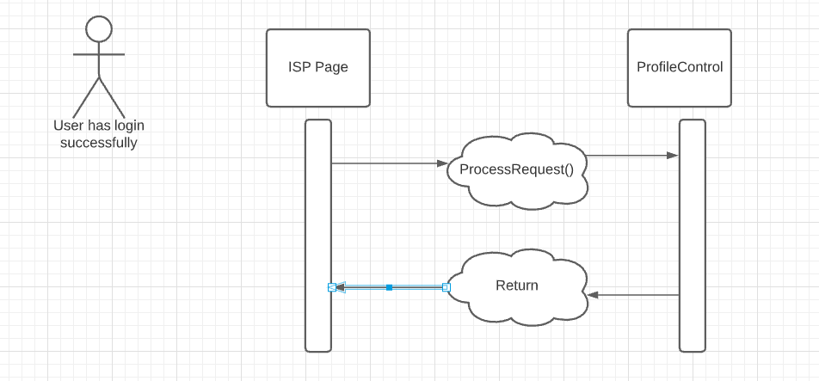

## 18. My Orders

### a. Class Diagram

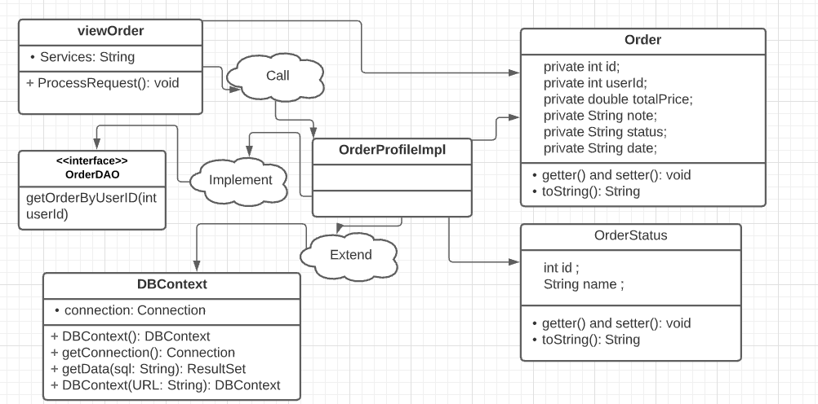

### b. Class Specifications

* viewOrderr:

|  |  |  |
| --- | --- | --- |
| No | Method | Description |
| 01 | processRequest() | - *Return: Null*  - *Parameter: HttpServletRequest request, HttpServletResponse response*  - *Receive request from client and process data with Database, then return a list containing all orders and put that data to jsp page* |

* OrderDAO:

|  |  |  |
| --- | --- | --- |
| No | Method | Description |
| 01 | getAllUsers() | - *Return: List<Order>*  - ***Parameter: UserID***  - *Get all the orders of a user in the database and return a list of orders* |

### c. Sequence Diagram(s)

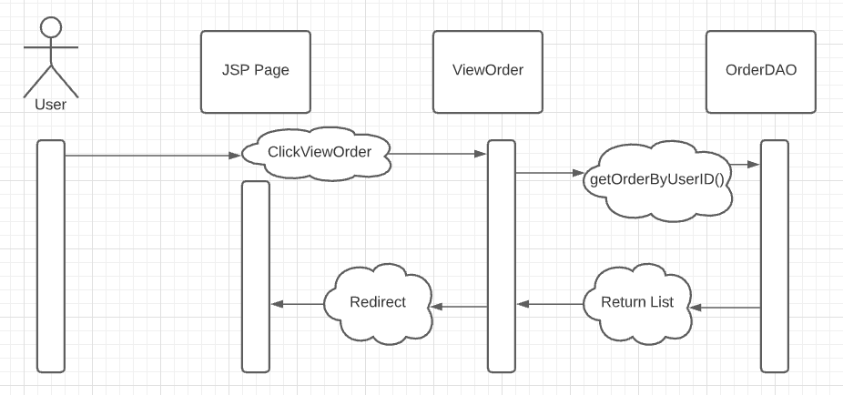

### d. Database queries

* SELECT o.ID, o.UserID, o.TotalPrice, o.Note, os.Name, o.DayBuy FROM Orders o INNER JOIN Order_Status os ON o.Status = os.ID WHERE o.UserId = ?

## 19. Order Information

### a. Class Diagram

### b. Class Specifications

### c. Sequence Diagram(s)

### d. Database queries

## 20. View Product List

### a. Class Diagram

### b. Class Specifications

### c. Sequence Diagram(s)

### d. Database queries

## 21. Orders List

### a. Class Diagram

### b. Class Specifications

### c. Sequence Diagram(s)

### d. Database queries

## 22. Order Details

### a. Class Diagram

### b. Class Specifications

### c. Sequence Diagram(s)

### d. Database queries

## 23. View Feedback

### a. Class Diagram

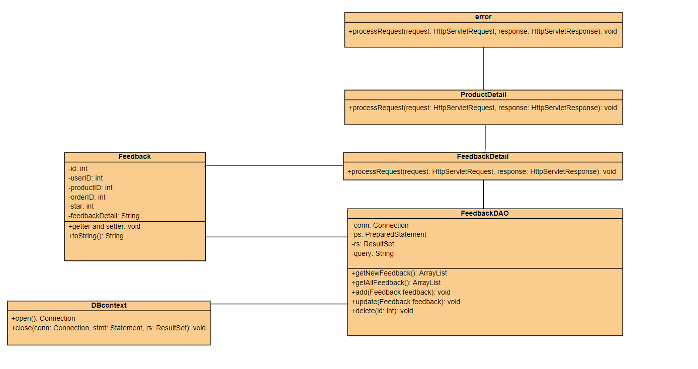

### b. Class Specifications

* FeedbackDetail class

|  |  |  |
| --- | --- | --- |
| **No** | **Method** | **Description** |
| *01* | *processRequest()* | *get blog detail from the database to display on ProductDetail.jsp* |

* FeedbackDAO class

|  |  |  |
| --- | --- | --- |
| **No** | **Method** | **Description** |
| *01* | *getNewFeedback()* | *Return: top 5 newest Feedback from database* |
| *03* | *getAllFeedback (int id)* | *Return: All Feedback of a product in database*  *input: id* |
| *04* | *add(Feedback feedback)* | *Add feedback with detail entered in addFeedback.jsp page*  *Return: null*  *Input: feedback* |
| *05* | *update(Feedback feedback)* | *Update feedback with detail entered in updateFeedback.jsp page*  *Return: null*  *Input: feedback* |
| *06* | *delete(int id)* | *Update feedback with id entered in updateFeedback.jsp*  *Return: null*  *Input: id* |

### c. Sequence Diagram(s)

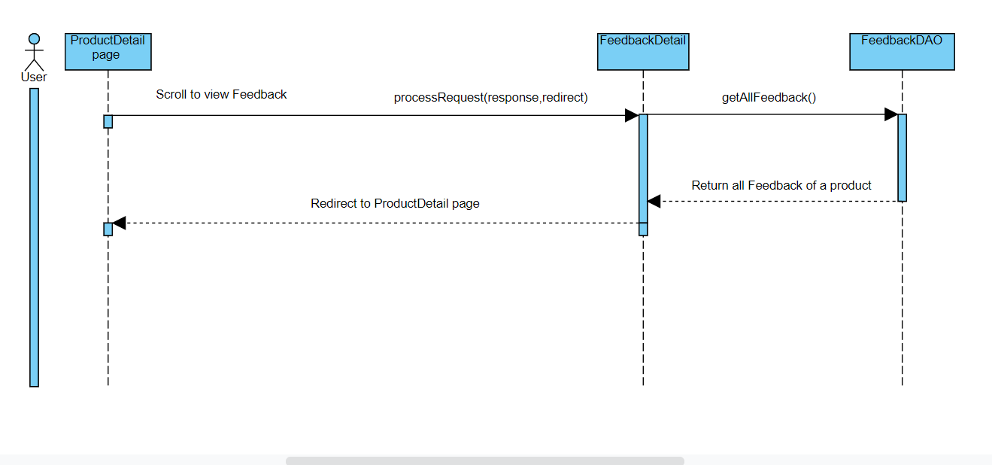

### d. Database queries

Select * from Feedback where productID=?

## 24. Send Feedback

### a. Class Diagram

### b. Class Specifications

### c. Sequence Diagram(s)

### d. Database queries

## 25. Blogs List

### a. Class Diagram

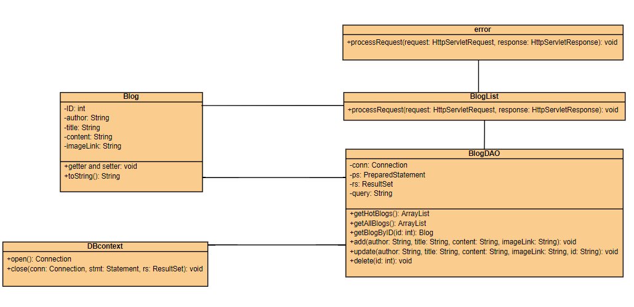

### b. Class Specifications

* BlogList class

|  |  |  |
| --- | --- | --- |
| **No** | **Method** | **Description** |
| *01* | *processRequest()* | *get blog list from the database to display on BlogList.jsp* |

* BlogDAO class

|  |  |  |
| --- | --- | --- |
| **No** | **Method** | **Description** |
| *01* | *getBlogByID(int id)* | *Return: Blog Detail where blog id contain parameter*  *Input: ID of blog* |
| *02* | *getHotBlogs()* | *Return: top 3 newest blog from database* |
| *03* | *getAllBlog()* | *Return: All blog in database* |
| *04* | *add(String author, String title, String content, String imageLink)* | *Add blog with detail entered in addBlog.jsp page*  *Return: null*  *Input: author, title, content, imageLink* |
| *05* | *update(String author, String title, String content, String imageLink, String id)* | *Update blog with detail entered in updateBlog.jsp page*  *Return: null*  *Input: author, title, content, imageLink, id* |
| *06* | *delete(int id)* | *Update blog with id entered in blogManage.jsp*  *Return: null*  *Input: id* |

### c. Sequence Diagram(s)

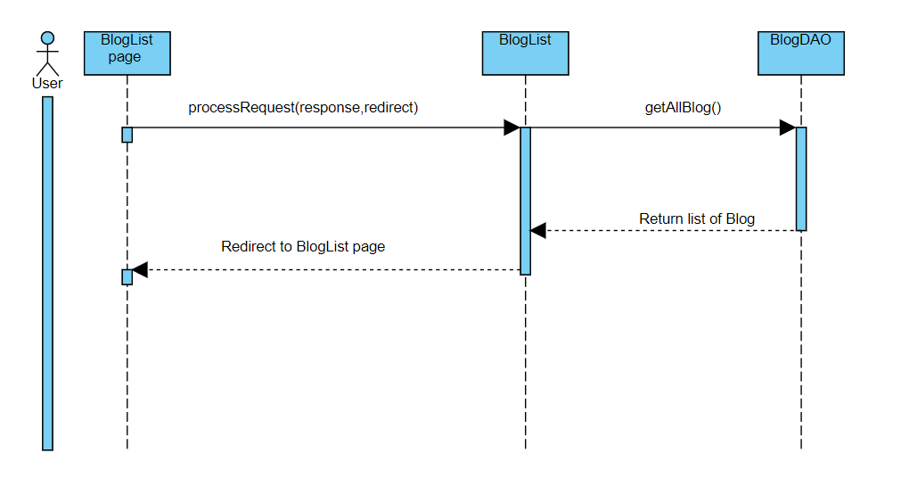

### d. Database queries

Select * from Blog desc

## 26. Blog Details

### a. Class Diagram

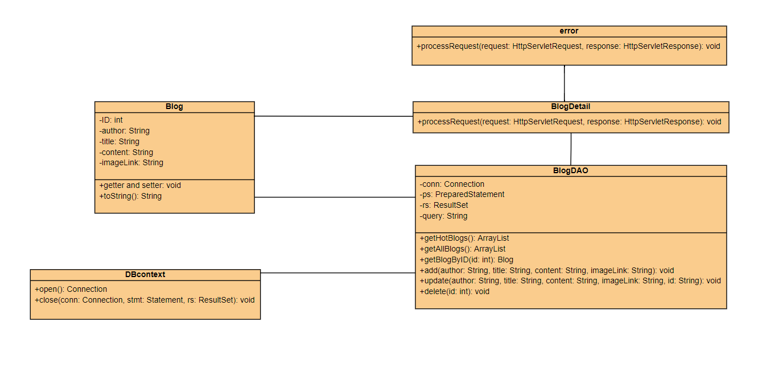

### b. Class Specifications

* BlogDetail class

|  |  |  |
| --- | --- | --- |
| **No** | **Method** | **Description** |
| *01* | *processRequest()* | *get blog detail from the database to display on BlogDetail.jsp* |

* BlogDAO class

|  |  |  |
| --- | --- | --- |
| **No** | **Method** | **Description** |
| *01* | *getBlogByID(int id)* | *Return: Blog Detail where blog id contain parameter*  *Input: ID of blog* |
| *02* | *getHotBlogs()* | *Return: top 3 newest blog from database* |
| *03* | *getAllBlog()* | *Return: All blog in database* |
| *04* | *add(String author, String title, String content, String imageLink)* | *Add blog with detail entered in addBlog.jsp page*  *Return: null*  *Input: author, title, content, imageLink* |
| *05* | *update(String author, String title, String content, String imageLink, String id)* | *Update blog with detail entered in updateBlog.jsp page*  *Return: null*  *Input: author, title, content, imageLink, id* |
| *06* | *delete(int id)* | *Update blog with id entered in blogManage.jsp*  *Return: null*  *Input: id* |

### c. Sequence Diagram(s)

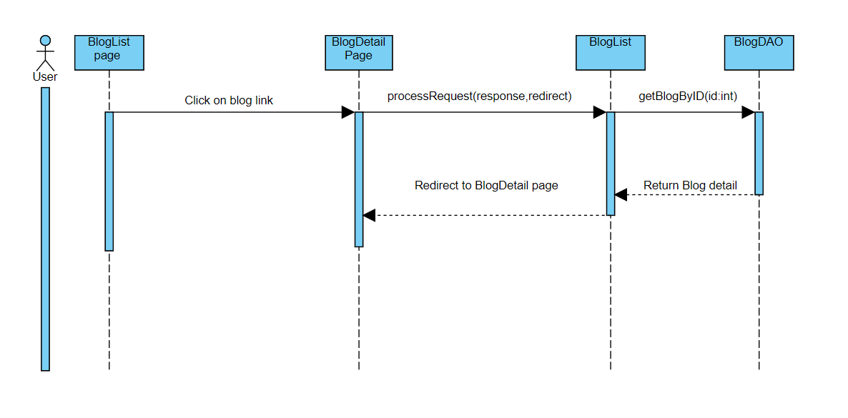

### d. Database queries

SELECT * FROM Blog WHERE ID = ?

## 27. Blog Management

### a. Class Diagram

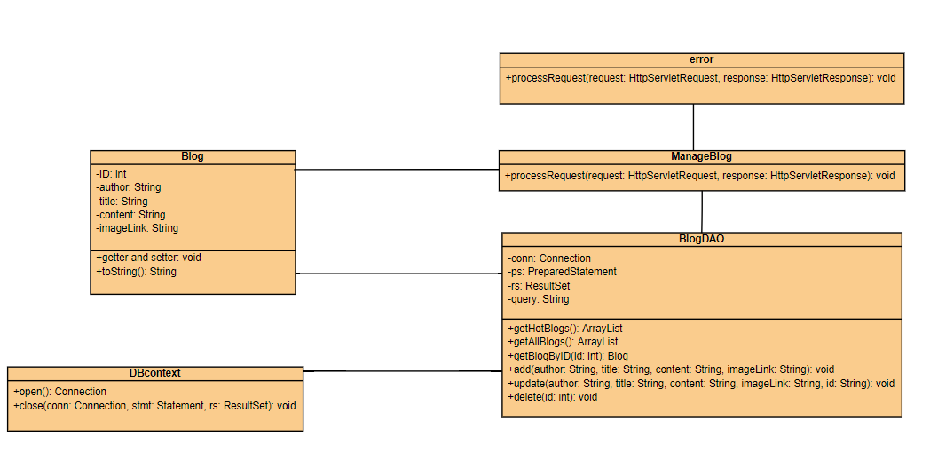

### b. Class Specifications

* ManageBlog class

|  |  |  |
| --- | --- | --- |
| **No** | **Method** | **Description** |
| *01* | *processRequest()* | *get blog detail from the database to display on ManageBlog.jsp* |

* BlogDAO class

|  |  |  |
| --- | --- | --- |
| **No** | **Method** | **Description** |
| *01* | *getBlogByID(int id)* | *Return: Blog Detail where blog id contain parameter*  *Input: ID of blog* |
| *02* | *getHotBlogs()* | *Return: top 3 newest blog from database* |
| *03* | *getAllBlog()* | *Return: All blog in database* |
| *04* | *add(String author, String title, String content, String imageLink)* | *Add blog with detail entered in addBlog.jsp page*  *Return: null*  *Input: author, title, content, imageLink* |
| *05* | *update(String author, String title, String content, String imageLink, String id)* | *Update blog with detail entered in updateBlog.jsp page*  *Return: null*  *Input: author, title, content, imageLink, id* |
| *06* | *delete(int id)* | *Update blog with id entered in blogManage.jsp*  *Return: null*  *Input: id* |

### c. Sequence Diagram(s)

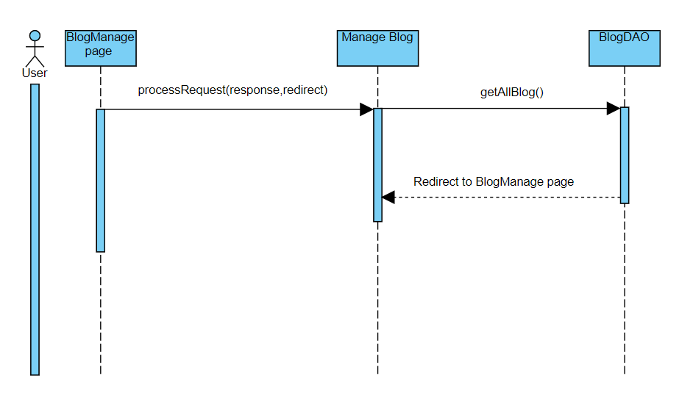

### d. Database queries

Select * from blog

## 28. View Notification

### a. Class Diagram

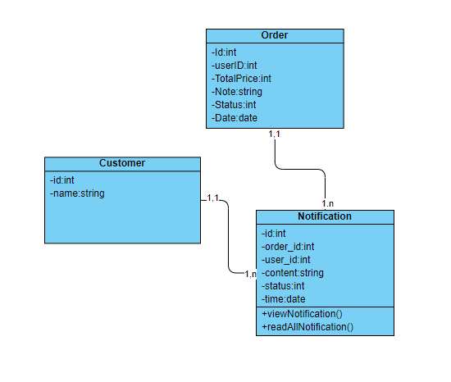

### b. Class Specifications

Notification class

|  |  |  |
| --- | --- | --- |
| **No** | **Method** | **Description** |
| *01* | *viewNotification()* | *get all notification from database for a user* |

### c. Sequence Diagram(s)

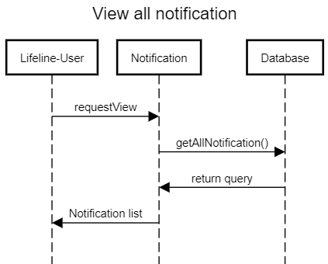

### d. Database queries

SELECT * from dbo.Notification where user_id = ?

## 29. Mark as Read

### a. Class Diagram



### b. Class Specifications

Notification class

|  |  |  |
| --- | --- | --- |
| **No** | **Method** | **Description** |
| *01* | *readAllNotification()* | *mark all notification as read* |

### c. Sequence Diagram(s)

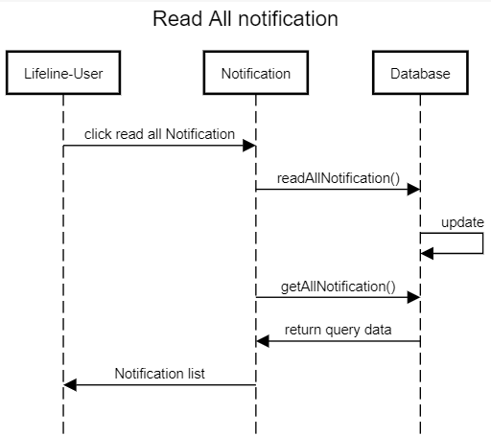

### d. Database queries

Update dbo.Notification

set status=1

where user_id=?

## 30. Admin Feature

### a. Class Diagram

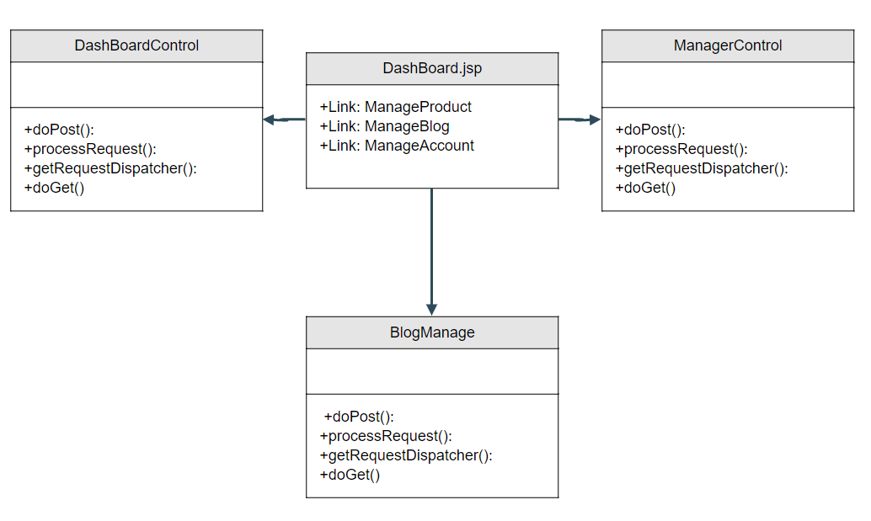

### b. Class Specifications

|  |  |  |
| --- | --- | --- |
| **No** | **Method** | **Description** |
| *01* | *processRequest()* | *get blog detail from the database to display on ManageProduct.jsp* |
| *02* | *processRequest()* | *get blog detail from the database to display on ManageAccount.jsp* |
| *03* | *processRequest()* | *get blog detail from the database to display on ManageBlog.jsp* |

### c. Sequence Diagram(s)

### d. Database queries

+select * from ...

## 31. Orders Dashboard

### a. Class Diagram

### b. Class Specifications

### c. Sequence Diagram(s)

### d. Database queries

## 32. Error

### a. Class Diagram

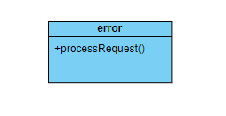

### b. Class Specifications

error Class

|  |  |  |
| --- | --- | --- |
| **No** | **Method** | **Description** |
| *01* | *processRequest()* | *Process and return error page html back to user* |

### c. Sequence Diagram(s)

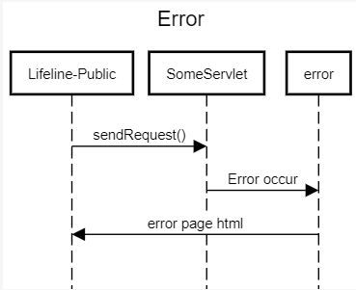

### d. Database queries

None

## 

# III. Database Tables

## 1. Database Schema

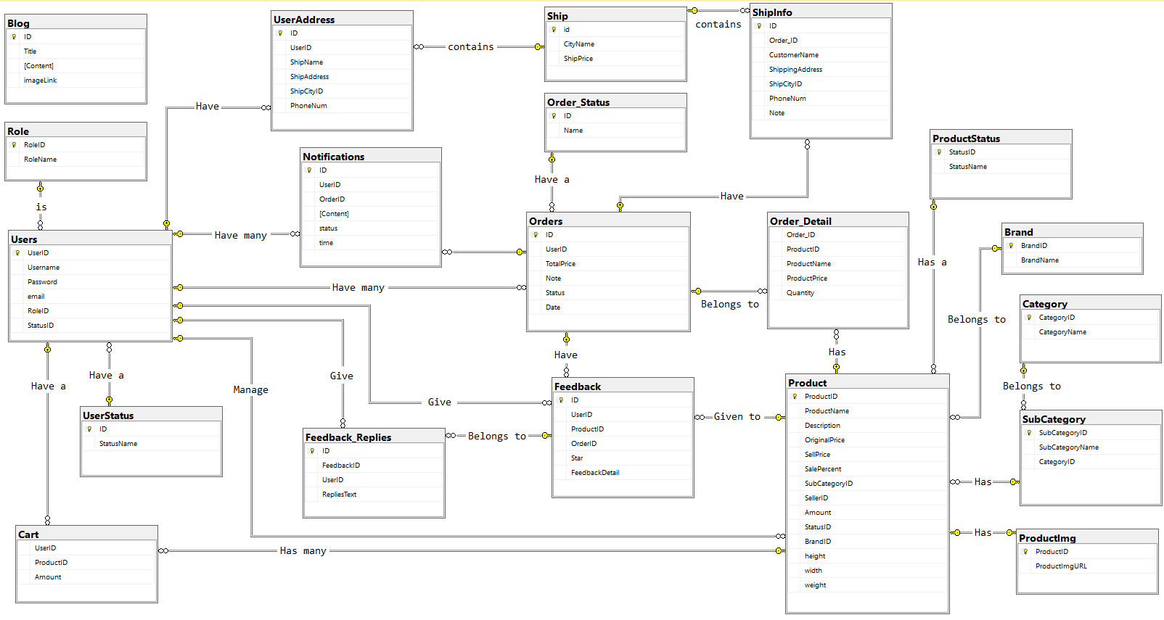

## 2. Table Description

|  |  |  |
| --- | --- | --- |
| **No** | **Table** | **Description** |
| *01* | *Blog* | *Blog content + image*  *- Primary keys: ID*  *- Foreign keys:* |
| *02* | *Role* | *Role of a user ( Admin,Marketing,Sale,Customer )*  *- Primary keys: RoleID*  *- Foreign keys:* |
| *03* | *UserStatus* | *Account activation status*  *- Primary keys: ID*  *- Foreign keys:* |
| *04* | *Ship* | *Shipping price for each city*  *- Primary keys: id*  *- Foreign keys:* |
| *05* | *Order_Detail* | *Detail of each product in order*  *- Primary keys:*  *- Foreign keys: OrderID, ProductID* |
| *06* | *UserAddress* | *Address for each user*  *- Primary keys:ID*  *- Foreign keys: UserID, ShipCityID* |
| *07* | *Users* | *Users*  *- Primary keys: UserID*  *- Foreign keys: RoleID,StatusID* |
| *08* | *Notification* | *Notification data*  *- Primary keys: ID*  *- Foreign keys: OrderID, UserID* |
| *09* | *ShipInfo* | *Shipping info for each order*  *- Primary keys: ID*  *- Foreign keys: Order_ID, ShipCityID* |
| *10* | *Order* | *Order data*  *- Primary keys: ID*  *- Foreign keys: UserID,Status* |
| *11* | *Feedback* | *Feedback of a product order*  *- Primary keys: ID*  *- Foreign keys: UserID,ProductID, OrderID* |
| *12* | *Feedback_Replies* | *Replies of feedbacks*  *- Primary keys: id*  *- Foreign keys: FeedbackID,UserID* |
| *13* | *Order_Status* | *Status of a order*  *- Primary keys: ID*  *- Foreign keys:* |
| *14* | *Product* | *Product Data*  *- Primary keys: ProductID*  *- Foreign keys: SubCategoryID,SellerID,StatusID,BrandID* |
| *15* | *Category* | *Category Data*  *- Primary keys: CategoryID*  *- Foreign keys:* |
| *16* | *SubCategory* | *Sub Category ID*  *- Primary keys: SubCategoryID*  *- Foreign keys: CategoryID* |
| *17* | *Productimg* | *Image of products*  *- Primary keys:*  *- Foreign keys: ProductID* |
| *18* | *ProductStatus* | *Status of a product*  *- Primary keys: StatusID*  *- Foreign keys: StatusName* |
| *19* | *Brand* | *Brand data*  *- Primary keys: BrandID*  *- Foreign keys:* |
| *20* | *Cart* | *Cart info for each user*  *- Primary keys: UserID*  *- Foreign keys: ProductID* |

## 